Node.js Notes

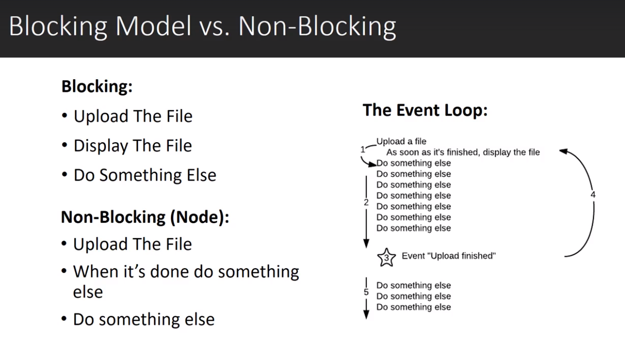

Google OAuth Setup

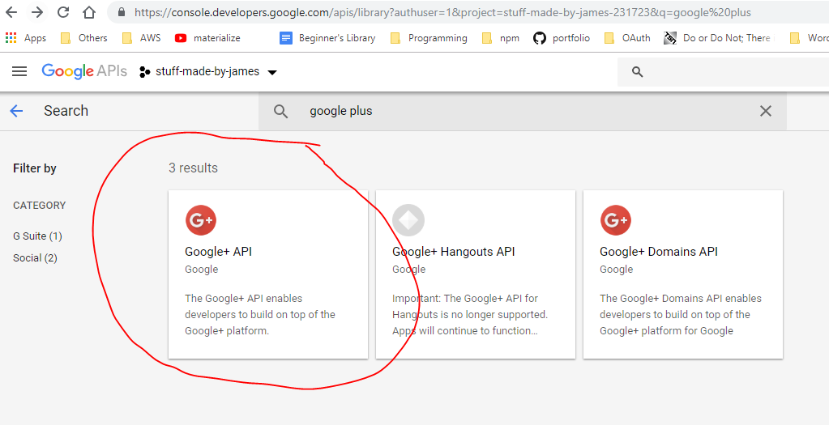

Download the app and add credentials to enable Google OAuth login

Heroku Setup

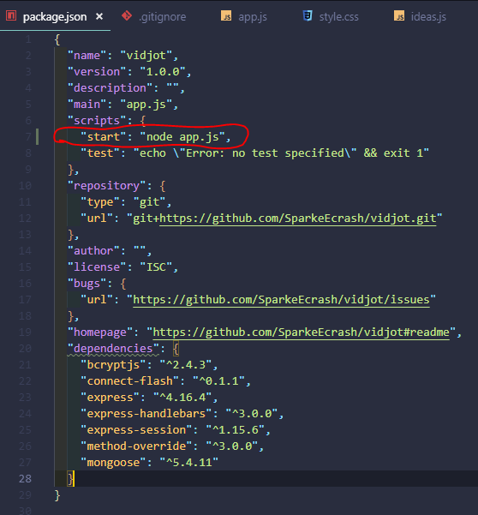

Setup start script for ‘npm start’

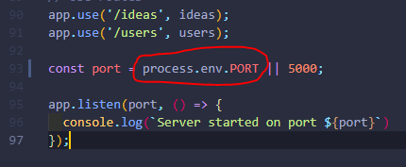

Setup ‘process.env.PORT’ to be the first port number value it takes for Heroku to set up its own PORT number for you (Heroku may not use 5000)

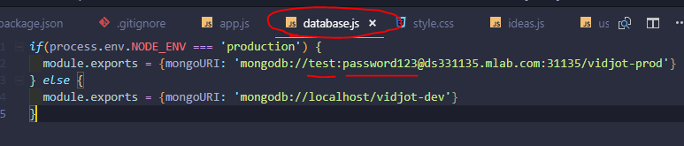

Setup database.js file which sets up the mongodb connection URI. If NODE_ENV is equal to ‘production’ make sure mongoURI is set to the remote database that is from mlab. The user name and password in the string is from the table below when you set up the users for the data table in mlab.

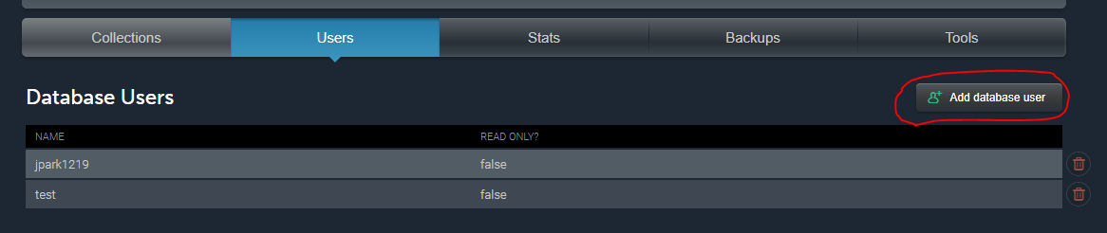

The other mongoURI in else statement is the local mongodb that uses Robo 3T as the GUI

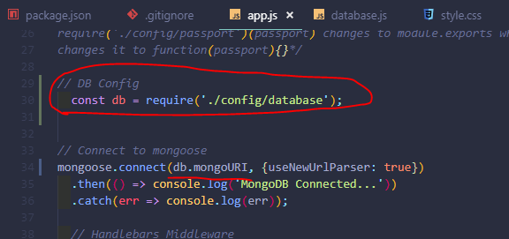

In the server.js or app.js file make sure that the mongo URI for mongoose.connect uses the configuration from database.js

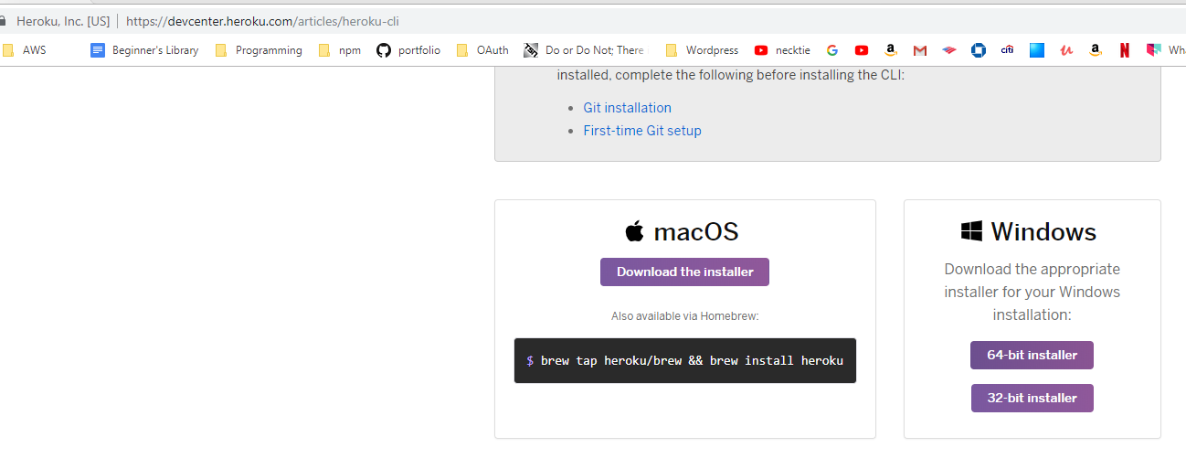Download heroku tool belt

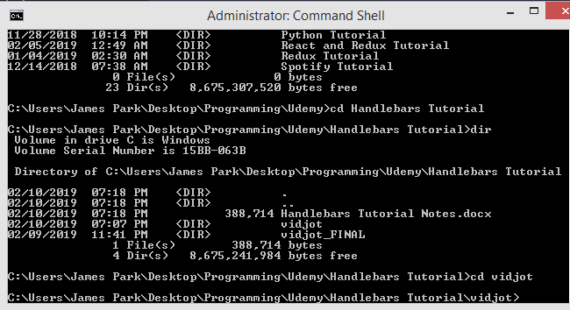

After download is completed, run command shell as administrator and navigate to project root directory

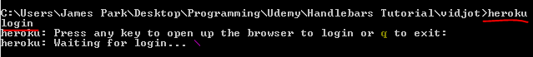

Enter ‘heroku login’ and press any key to open login webpage

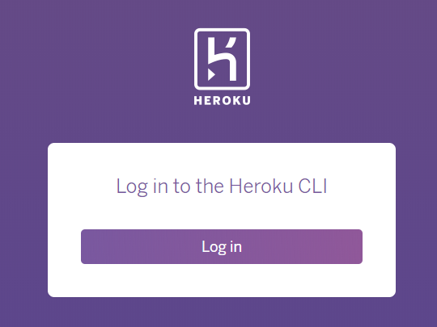

Login with Heroku account

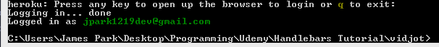

Run ‘heroku create’

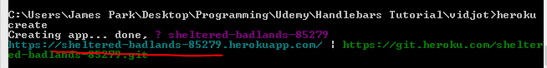

Check dashboard

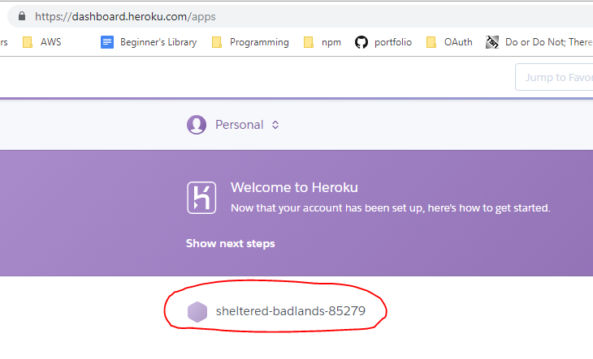

Click app and click deploy

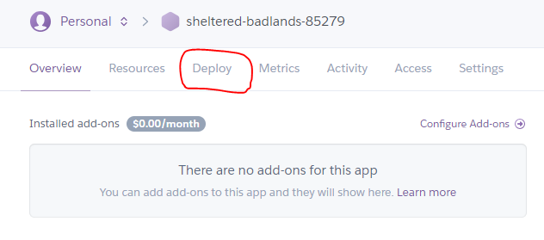

FIRST MAKE SURE YOUR APP IS UPLOADED ON GITHUB IN A SEPARATE REPO

Copy the link below excluding the dollar sign

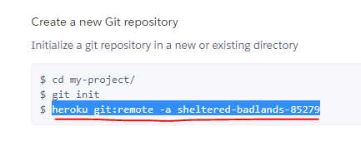

Paste link below to command shell and run it



Run ‘git push heroku master’

**NOTE: Make sure the branch master you push to heroku has ALL the heroku configuration settings**

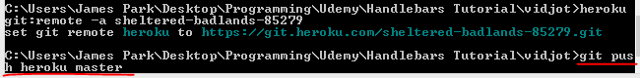

Click Open App or run ‘heroku open’

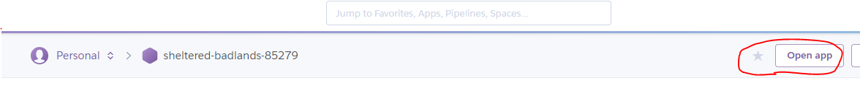

OR



You will see the results

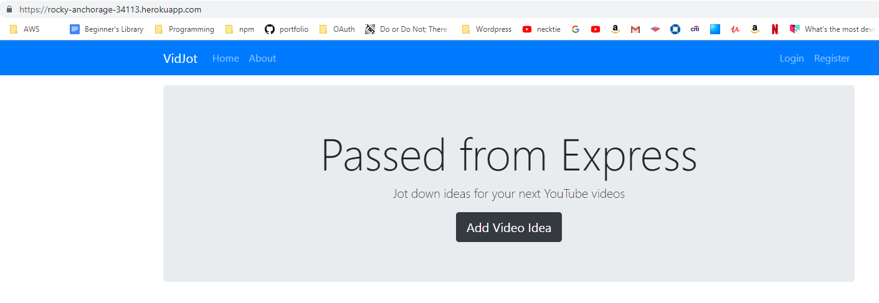

NOTE

MAKE SURE ALL THE DEPENDENCIES ARE LISTED CORRECTLY FOR HEROKU TO CORRECLTY NPM INSTALL ALL THE NECESSARY PACKAGES. IF PACKAGES ARE MISSING HEROKU WILL GENERATE A ‘CODE=H10 DESC=”App crashed”’ ERROR MESSAGE

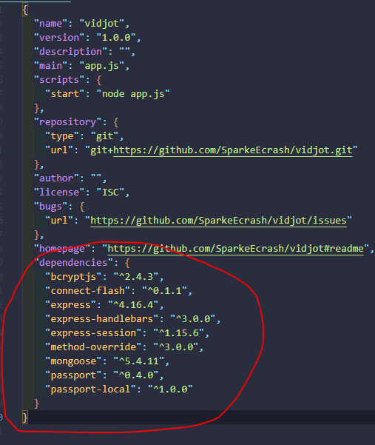

Changing Domain Name

Log into NameCheap and get the domain name you want to use

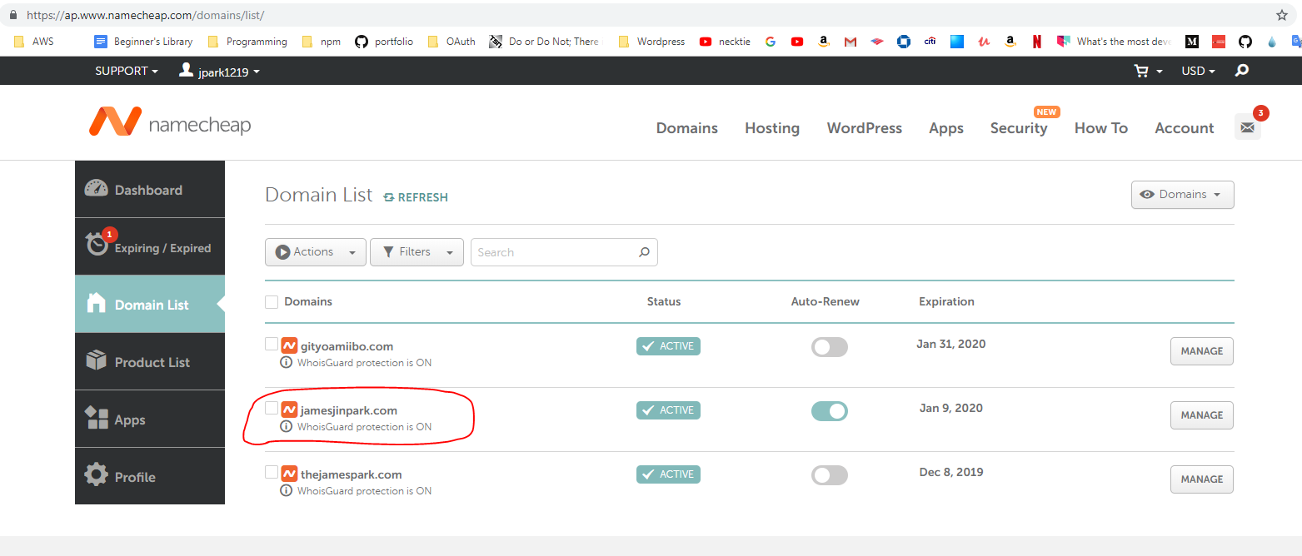

Make sure you have a credit card registered to your Heroku account

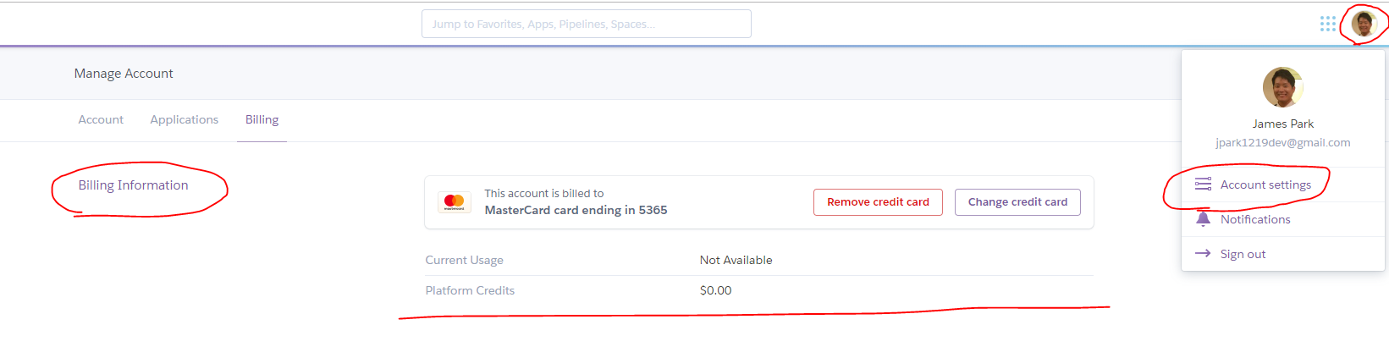

Go to Heroku and go to Settings Tab

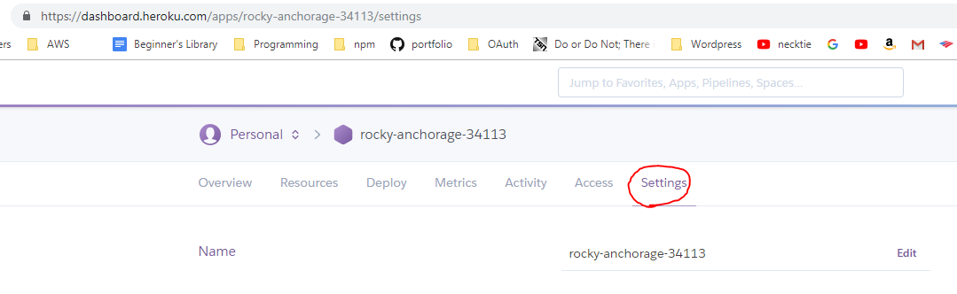

Click ‘Add domain’

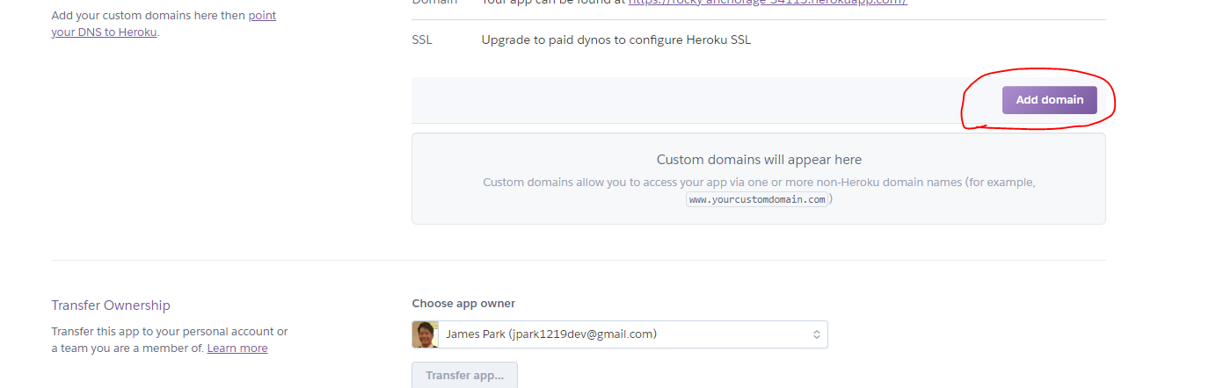

Add domain name

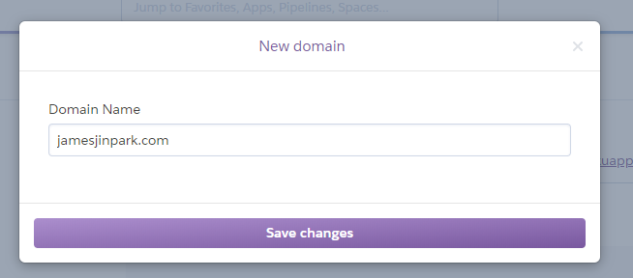

Include “www.” version

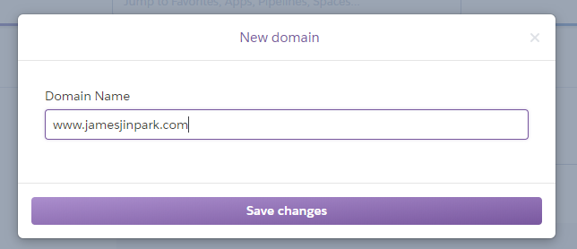

Copy the DNS Target

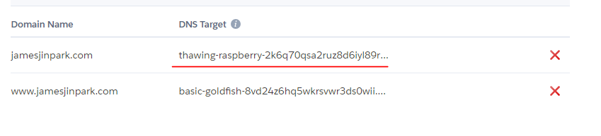

On Name Cheap click Manage for the url



Click Advanced DNS

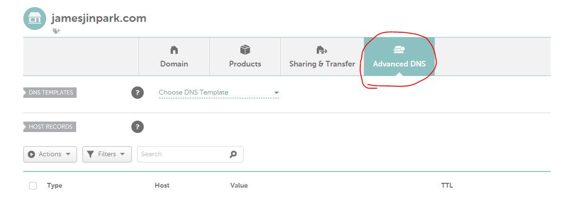

Paste the Target DNS at the location below and click green check mark to save

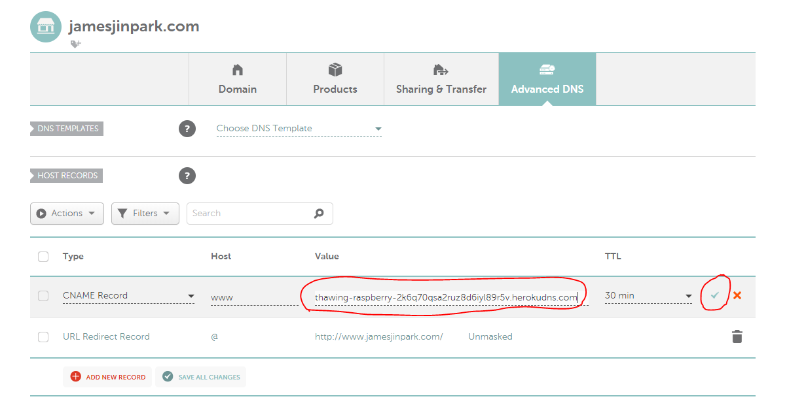

NOTE: The below” URL Redirect Record” makes it so that url’s without the ‘www.’ prefix gets redirected to the same link with ‘www.’ added to it

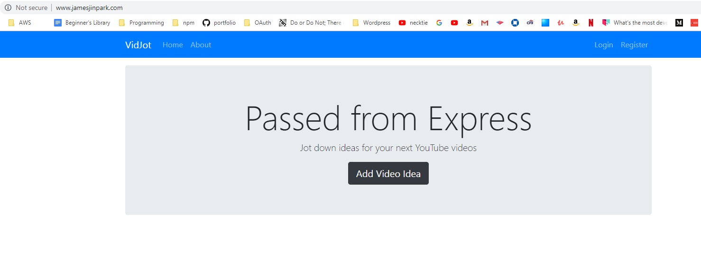

The url is now set up to the heroku DNS target address

Adding Config Variables

Set up different key files

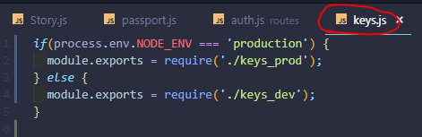

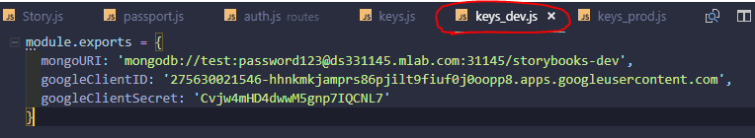

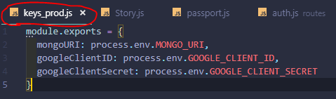

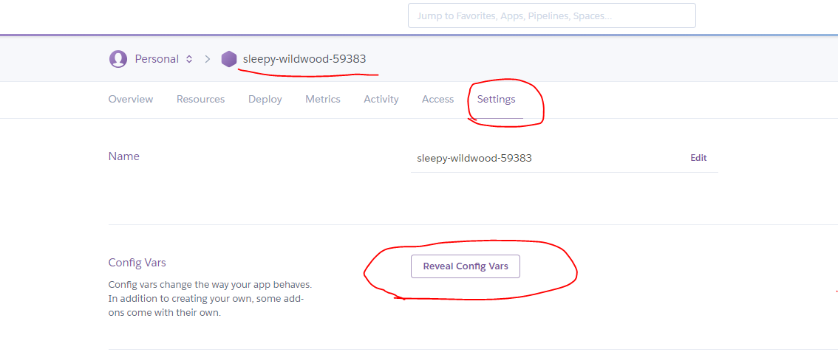

Click Reveal Config Vars

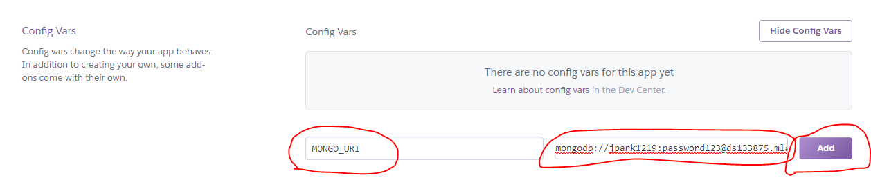

Enter Config Vars

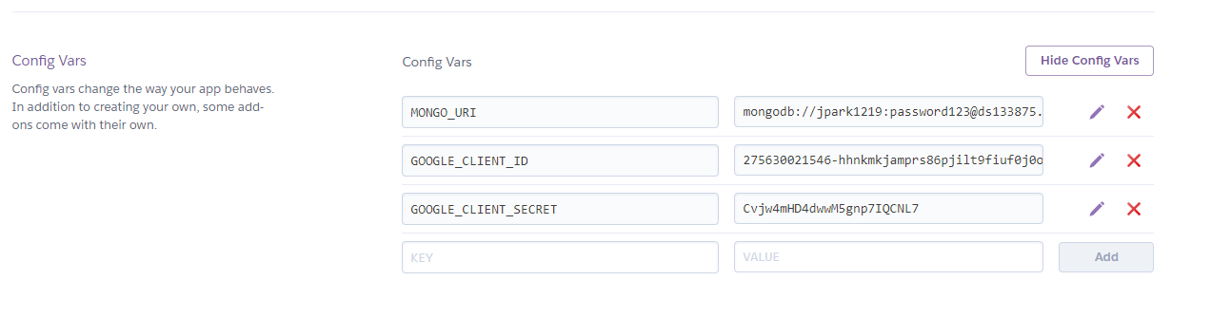

Make sure to enter all of them

Make Sure to Change Google OAuth or Other Passport OAuth Credentials

